
POSITION DESCRIPTION

POSITION TITLE: General Manager Business Transformation (GMBT)

LOCATION: National role (based in Auckland with travel across NZ)

REPORTS TO: Chief Executive Officer (CEO)

DIRECT REPORTS: Business Transformation Team (8 FTE)

PURPOSE:

The General Manager – Business Transformation is a key member of SPCA New Zealand’s Senior Leadership Team and is responsible for driving organisational performance, efficiency, and capability through strategic improvement initiatives. The role leads process improvement, project delivery, content strategy, and data strategy—ensuring SPCA operates with consistency, clarity, and evidence‑based decision making.

This position champions organisational transformation, cross‑functional collaboration, and the development of systems and processes that support better outcomes for animals, people, and communities across Aotearoa.

KEY ACCOUNTABILITIES: | KEY RESPONSIBILITIES:
1. Organisational Performance & Process Improvement | - Lead SPCA’s business improvement strategy and identify opportunities to streamline operations and reduce variation across centres.  - Develop frameworks and tools that embed continuous improvement practices.  - Partner with operational leaders to design and implement improvement initiatives that enhance service quality and efficiency.
2. Project Delivery Leadership | - Oversee the organisation’s project portfolio, ensuring initiatives are prioritised, resourced, and delivered to agreed scope, time, and budget.  - Strengthen project governance and build project management capability across teams.  - Manage programme-level risks, dependencies, and benefits.

Updated December 2024

3. Content Strategy & Knowledge Management | - Lead the development, governance, and maintenance of organisational content including policies, procedures, guidelines, and training materials.  - Ensure content is accurate, accessible, consistent across SPCA, and aligned with regulatory requirements.  - Drive improvements in knowledge-sharing and support centres in adopting standardised content.
4. Data Strategy & Insights | - Lead SPCA’s data strategy, improving data quality, accessibility, reporting, and analytics capability.  - Oversee delivery of dashboards and insights that inform operational and strategic decisions.  - Promote data literacy and uplift capability across the organisation.
5. Leadership & Collaboration | - Contribute to organisation-wide strategy, culture, and planning as a member of the Senior Leadership Team.  - Build a high-performing Business Improvement team across improvement, data, content, and project delivery.  - Foster strong working relationships across all levels of the organisation.
6. Change Management & Transformation Delivery | - Lead major organisational change initiatives, ensuring adoption and minimal disruption to animal care and service delivery.  - Develop and execute change strategies, communication plans, and training resources.  - Enable SPCA to evolve toward a more integrated and performance-driven organisation.
7. Strategic Contribution | - Provide timely, high-quality strategic advice to the CEO and Senior Leadership Team.  - Contribute to the development and delivery of SPCA’s strategic plan and long-term transformation goals.  - Influence strategic decisions through evidence, insights, and organisational performance data.
8. Actively contributes to Health & Safety | - Ensure compliance with the Health and Safety Act 2015 by:  - taking reasonable care of your own health and safety and ensure that you don’t cause harm to others  - complying with all health and safety instructions, policies or procedures and compliance

Overall Accountabilities
Process Improvement
- Delivery of efficiency gains (financial or time savings).
- Improvement initiatives completed and achieving targeted outcomes.
- Measurable reduction in operational variation.
- Stakeholder satisfaction >85%.

Project Delivery
- Projects delivered on time, within scope, and within budget.
- Project benefits realisation rate at or above planned targets.
- Improvement in project management maturity and governance adoption.

Content Strategy
- All core documents reviewed/updated in line with schedule.
- User satisfaction >80% with content accessibility and quality.
- Consistent use of organisation-wide content across centres.

Data Strategy
- Reduction in data errors or missing information.
- Delivery of dashboards/insights by agreed timelines.
- Increased adoption of data tools and data literacy.

Leadership & Collaboration
- Positive team engagement results.
- Strong retention and development of metrics.
- Positive collaboration and leadership feedback from SLT.

Change Management
- Adoption targets met for key initiatives.
- Successful implementation with minimal operational disruption.
- High-quality change planning and execution.

Strategic Contribution
- Timely, actionable strategic advice.
- Contribution to milestones in SPCA’s strategic plan.
- Demonstrated influence on organisation-wide improvement.

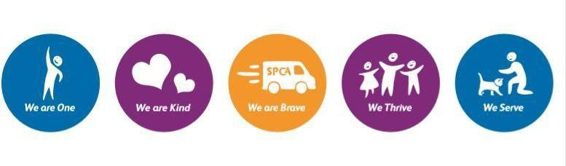

This position description has been designed to indicate the general nature and level of work performed by employees within this position. The actual duties, responsibilities, and qualifications may vary. It is not the intention to limit the scope or the function of the position. Duties and responsibilities can be amended from time to time by the Employer to meet any changing condition.
SPCA is an equal opportunity employer and does not discriminate against individuals on the basis of race, gender, age, national origin, religion, marital status, veteran status, or sexual orientation.

