
POSITION DESCRIPTION

POSITION TITLE:

LOCATION:

REPORTS TO:

Philanthropy Relationship Manager

(25 hours per week)

As per employment agreement

National Philanthropy Manager

PURPOSE:
The Philanthropy Relationship Manager nurtures and strengthens relationships with a defined portfolio of SPCA’s Major Donors - the compassionate people whose generosity drives life-changing outcomes for animals across New Zealand.

This part-time role combines strategic relationship management with a strong focus on income growth and donor prospecting. A key priority is to identify, qualify, and cultivate new potential Major Donors from within SPCA’s extensive supporter database, converting interest into deep, long-term philanthropic partnerships.

It is both people-focused and data-informed - blending empathy with insight to understand each donor’s motivations, communicate SPCA’s impact through powerful storytelling, and present compelling opportunities to invest in transformational change.

By growing the Major Donor pipeline and strengthening existing relationships, this role contributes directly to SPCA’s financial sustainability and long-term vision: a world where all animals are respected and treated with kindness.

Working collaboratively with the Philanthropy and wider Fundraising teams, this role drives the expansion and retention of SPCA’s Major Donor base, ensuring sustainable revenue growth through exceptional stewardship, communication, and relationship management.

KEY ACCOUNTABILITIES: | KEY RESPONSIBILITIES:
- Relationship Management and Stewardship | - Manage, nurture, and grow a defined portfolio of Major Donors to achieve income and retention targets.  - Build trusted, long-term relationships through regular, personalised contact — calls, meetings, and tailored communication.  - Develop and deliver individual cultivation and stewardship donor plans aligned with each donor’s values, interests and gift timing.  - Use the Moves management cycle including the 5 I’s (Identification, Inform, Interest, Involve and Invest) to build Major Donor relationships and funding.  - Confidently discuss SPCA’s work, current needs, and giving opportunities in a way that’s personal and meaningful.  - Provide timely, high-quality impact reports and updates that demonstrate the tangible results of their giving.  - Ensure every donor feels recognised, appreciated, and connected to the change they help create.  - Resolving issues or complaints relating to Major donors in a timely manner.
- Donor Growth, Prospecting and Income Generation | - Achieve annual Major Donor income targets through proactive engagement, cultivation, and solicitation.  - Identify and qualify new potential Major Donors within SPCA’s supporter base through database analysis, prospect profiling, and collaboration with the wider Fundraising team.  - Support the conversion of Mid-Level and new prospects into Major Donors by developing thoughtful cultivation plans and introducing appropriate giving opportunities.  - Confidently present funding propositions and cases for support that align SPCA’s priorities with donor passions.  - Maintain focus on long-term donor value and return on investment to ensure sustainable revenue growth.  - Works with the Engagement team to understand and integrate appropriate Major donor communications with the wider donor communications calendar.
- Programme and Team Contribution | - Contribute insights, portfolio learnings, and donor feedback to inform the national Major Donor strategy.  - Collaborate with Philanthropy, Grants, and Communications teams to coordinate messaging and align stewardship activities.  - Provide accurate and timely reporting on portfolio performance, income progress, and pipeline development.  - Share success stories and ideas that support a culture of accountability, innovation, and shared achievement.
- Administration, Data Management and Compliance | - Maintain accurate and up-to-date records of all donor and prospect interactions in SPCA’s CRM (Raiser’s Edge).  - Track engagement, pipeline movement, and giving patterns to support monitoring of targets and trends.  - Ensure donor privacy, data management, and communications comply with ethical fundraising standards and SPCA policies.
- Health, Safety and Wellbeing | - Ensures compliance with the Health and Safety Act 2015 by:  - Take reasonable care of own health and safety and ensure actions do not cause harm to others.  - Comply with all SPCA health and safety policies, procedures, and reporting requirements.
- Other duties | - Support SPCA events, donor visits, and campaigns as required.  - Duties and responsibilities described above should not be construed as a complete and exhaustive list as it is not the intention to limit the scope or the functions of the position. Duties and responsibilities can be amended from time to time by the Employer to meet any changing condition.

INTERNAL FUNCTIONAL RELATIONSHIPS:

• All SPCA Employees and Management
• Volunteers

EXTERNAL FUNCTIONAL RELATIONSHIPS:
- Major Donors and Prospective Donors
- Supporters and Members of the Public

PERSON SPECIFICATION:
Qualifications, Skills, Knowledge, and Experience
Essential
- Minimum 5 years’ experience in relationship management, or philanthropy, with a proven record of achieving financial targets.
- Experience prospecting and qualifying new potential donors using CRM systems and data insights.
- Strong understanding of donor motivation, fundraising principles, and ethical best practice.
- Exceptional communication and storytelling skills - written, verbal, and interpersonal.
- Confident presenting to and engaging with high-net-worth individuals.
- Highly organised and results-focused, with strong attention to detail and follow-through.
- Proactive, self-motivated, and resilient, with the ability to work independently and collaboratively.
- Competent in CRM systems (preferably Raiser’s Edge), Microsoft Office suite and ChatGPT or other AI system.
- Full, clean driver’s licence.
- Commitment to SPCA’s mission, values, and vision.

Desirable
- Experience in philanthropy, donor development, or customer loyalty roles.
- Background in not-for-profit or membership-based organisations.
- Familiarity with data analysis, performance reporting, or dashboard tools (e.g. Power BI).

Personal attributes
- Results-driven and motivated by achieving income, retention, and growth targets.
- Warm, authentic communicator who builds rapport and trust quickly.
- Strategic thinker who balances empathy with business acumen.
- Professional and confident when discussing giving opportunities.
- Positive, resilient, and adaptable under pressure.
- Team-oriented, collaborative, and generous with insights and support.
- Passionate about SPCA’s mission and connecting people to purpose.
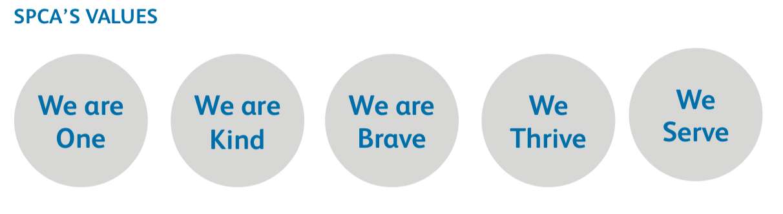

HOURS OF WORK
25 hours per week, with flexibility to attend meetings or events outside standard hours when required.

