POSITION DESCRIPTION

POSITION TITLE:

LOCATION:

REPORTS TO:

Philanthropy Relationship Manager

As per employment agreement

National Philanthropy Manager

PURPOSE:

The Philanthropy Relationship Manager will own and drive the growth of SPCA’s Mid-Level Donor Programme, with a strong focus on building and maintaining relationships directly via phone.

This is an exciting opportunity to help shape the future of animal welfare in New Zealand by building lasting, meaningful relationships with the people who make our work possible.

Mid-Level Donors are typically those giving between $1,000 and $5,000 annually.

The role is to fund SPCA services and initiatives that align with SPCA strategic objectives. The role focuses on excellent story-led communication, working cross-departmental as well as the management and accountability of donor funding, to provide sustainable donor revenue for the organisation.
This role is critical in turning mid-level supporters into long-term, high-value donors through personal contact, tailored communications, and consistent stewardship. The person in this role must be comfortable, confident, and skilled at picking up the phone, having authentic conversations, and asking for support.
The role is responsible for maintaining and growing the Mid-Level donor revenue stream, donor stewardship and strengthening those relationships, while meeting budgets.

The role works in collaboration with the wider fundraising team especially the Special Donor and Grants teams and to provide a strategic approach to funding projects.

KEY ACCOUNTABILITIES: | KEY RESPONSIBILITIES:
- Programme Leadership | - Lead the delivery of SPCA’s 3-Year Middle Donor Strategy  - Build a pipeline to Special Donors by increasing the number of donors who give in the $3k-$5k range.  - Increase the number of Mid Value donors who are also in the Legacy pipeline  - Manage and optimise donor segmentation and journey mapping  - Ensure the programme delivers meaningful and measurable results  - Work collaboratively with the Campaign Development team to identify opportunities to offer tailored variants of current programmes to achieve the best result from the Mid-Level Giving programme.  - Understand middle donor crossovers with other SPCA donor groups (e.g. Guardians, special donors, Giving Hearts Programme etc.) and manages relationships accordingly
- Donor Stewardship & Engagement | - Develop an individual cultivation strategy for each middle donor in the direct relationship portfolio  - Implement a tailored stewardship programme for Middle Donors using phone, mail, and digital channels  - Ensure each donor receives timely, personalised thank-yous and updates  - Coordinate exclusive content (e.g. webinars, behind-the-scenes stories) to build donor loyalty  - Make outbound phone calls to Mid-Level Donors to thank, engage, steward, and upgrade gifts.  - Develop and maintain warm, long-term relationships with donors through conversation and active listening.  - Capture their interests and passions.  - Confidently discuss SPCA’s work, current needs, and giving opportunities in a way that’s personal and meaningful  - Create and follow individual call plans for key donors throughout the year (e.g. warm-up, soft ask, hard ask)  - Track behaviour signals, income, upgrades, and retention targets  - Ensure funding relationships are appropriate to protect the SPCA brand and reputation.  - Where appropriate steward donors by inviting them to events and stewarding them with newsletters, Annual reports, etc.  - Monitor donor retention, and bring back lapsing donors
- Develop Cases for Support to match the donors’ interests and passions. | - Write and submit personalised, story-led, evidence based, compelling, emotionally stirring, and engaging case for supports, follow-ups, and accountability reports.
- Campaigns & Upgrades | - Run regular upgrade campaigns via phone and digital for regular givers and one-off donors  - Collaborate on appeals and fundraising campaigns with tailored MD messaging  - Use phone conversations to test asks, gain insights, and drive campaign performance
- Data & Reporting | - Work closely with Data & Insights to identify prospects, manage lists, and track donor interactions  - Maintain accurate call notes and activity tracking in Raiser’s Edge (RE)  - Report mothy and quarterly on results, trends, and opportunities
- Cross-Team Collaboration | - Coordinate with the Special Donor and Legacy teams to manage the donor pipeline  - Ensure seamless handover of prospects moving up and down the giving ladder  - Contribute to donor care alignment across fundraising channels
- 7. Supports process improvement groups and projects across the organisation to improve organisational performance. | - Actively participates in these groups and works collaboratively with all employees to achieve goals.  - Carries out project work as requested.
- Actively contributes to Health & Safety. | - Ensures compliance with the Health and Safety Act 2015 by:  - taking reasonable care of own health and safety and ensure that you don’t cause harm to others.  - complying with all health and safety instructions, policies, or procedures.  - ensuring health and safety compliance; including but not limited to:  - prompt investigation of reported incidents, risks, and unsafe practices (commence within 12 hours)  - training is completed within the mandatory timeframes.
- Carries out other duties as required from time to time. | - Provides support and assistance to SPCA events and campaigns as requested.  - Duties and responsibilities described above should not be construed as a complete and exhaustive list as it is not the intention to limit the scope or the functions of the position. Duties and responsibilities can be amended from time to time by the Employer to meet any changing condition.

INTERNAL FUNCTIONAL RELATIONSHIPS:

• All SPCA Employees and Management
• Volunteers

EXTERNAL FUNCTIONAL RELATIONSHIPS:
- Donors
- SPCA Support Office Staff
- Members of the public

PERSON SPECIFICATION:
Qualifications, Skills, Knowledge, and Experience
Essential
- Three to five years’ experience in Mid-Level Donor fundraising, or sales relationship management.
- Target driven - Committed to achieving the annual financial goal of the grant team.
- Comfortable making outbound phone calls daily - calls are the core of this role
- Strong interpersonal and verbal communication skills; warm, clear, persuasive
- Ability to confidently discuss fundraising needs and invite donations
- Experience managing supporter journeys and maintaining detailed call records
- Passion for building donor relationships and connecting people with purpose
- Organised, reliable, proactive, and target-driven
- Highly IT literate and can produce Raisers Edge reports and use internal IT systems extensively.
- Collaborative nature: Willingness to share insights and findings with SPCA Teams.
- Contribute to SPCA’s culture by role modelling ONE SPCA values day to day.
- Project management: Ability to juggle multiple relationships simultaneously without sacrificing quality.
- Adaptability: Ability to shift between strategic and detail-focused tasks based on workload demands.

Desirable
- Intermediate level usage of Raiser’s Edge or similar CRM, Excel, ChatGPT, Grok and Power BI will be an advantage
- Background in donor development, philanthropy, or customer loyalty
- Experience working in a charity, membership-based organisation, or fundraising team
- A sound understanding and empathy with the goals and values of the SPCA.

Personal attributes
- Strong relationship building and communication skills, in addition to analytical capabilities.
- Positive, resilient, and able to persevere to achieve desired results.
- Excellent written and oral communication skills.
- Highly organised with the ability to prioritise, multitask, meet expected deadlines, and achieve revenue targets.
- A commitment to high quality work and professionalism.
- Self-motivated and able to use initiative.
- Ability to manage confidential information with responsibility and integrity.
- A team player, keen to engage others across the organisation, provide guidance when sought, and generally contribute positively to the team and organisational culture.
- Ability to manage stress and handle emotional situations with empathy.
- Understands own limitations.
- Holds courage to face and deal with difficult people and issues.
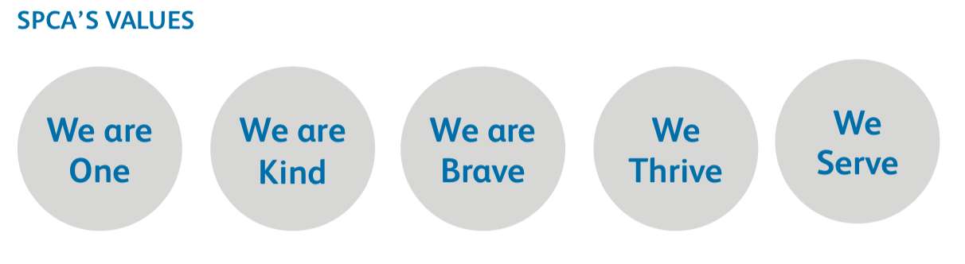
- Ability and willingness to travel on an as needed basis.

